Introduction
The Student Information System (SIS) is a web-based platform designed to help manage and organize academic information digitally. The purpose of this system is to provide an easier and more efficient way to store and retrieve student data, subjects, and enrollment records. Instead of manually writing information on paper, this system allows users to add, edit, view, search, and delete records using a simple interface. The system was developed using HTML, CSS, JavaScript for the frontend and PHP with MySQL for the backend. Overall, this system improves record management accuracy, reduces errors, and saves time.

Database Design
The database consists of three main tables: Students, Subjects, and Enrollments. These tables are connected to each other using primary and foreign keys to manage relationships.

ER Diagram
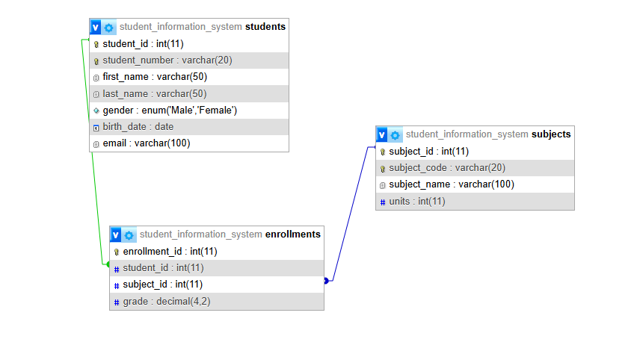
Table Name | Description
students | Stores basic student information such as student number, first name, last name, and course.
subjects | Contains subject details including subject code, name, and units.
enrollments | Acts as a link between students and subjects while storing grade information.
Table Descriptions

Relationships
- One student can enroll in many subjects.
- One subject can be enrolled by many students.
- The enrollments table connects both tables through foreign keys.

Web Interface
The system includes multiple pages with the following functionalities:
Students Page – Allows adding, editing, searching, and deleting student information.
Subjects Page – Lets the admin add new subjects, search existing ones, and remove or update them.
Enrollments Page – Used to enroll students in subjects and assign grades. The grade input can be edited later if needed.
Navigation Bar and Header – Gives consistent layout and easy movement between pages.
Each section includes a data table that automatically displays and updates information based on the user input, allowing users to easily view, manage, and track records.

Challenges and Learning
During the development of this system, several challenges were encountered. Setting up the database connection and linking the frontend to the backend was one of the most difficult parts. Debugging errors such as database connection issues, "Not Found" errors, and problems with script linking required patience and problem-solving. Designing the user interface and making it consistent across pages also took time.
Through this project, I learned how databases work with web applications and how CRUD operations are applied in real systems. I also gained a better understanding of HTML, CSS, JavaScript, and PHP. Overall, this project improved my confidence in building functional web applications and strengthened my logical thinking and debugging skills.

